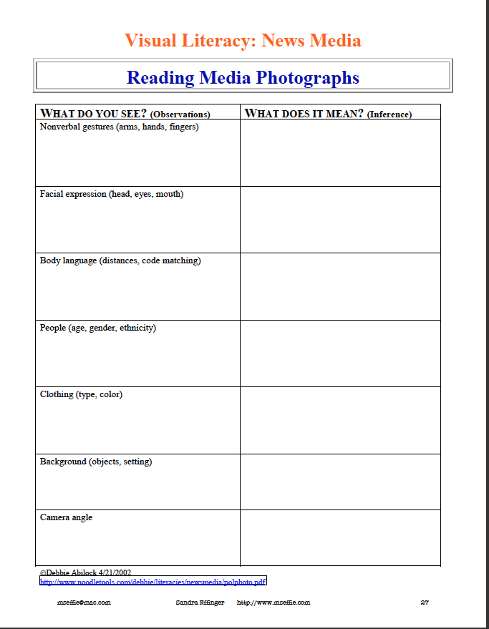
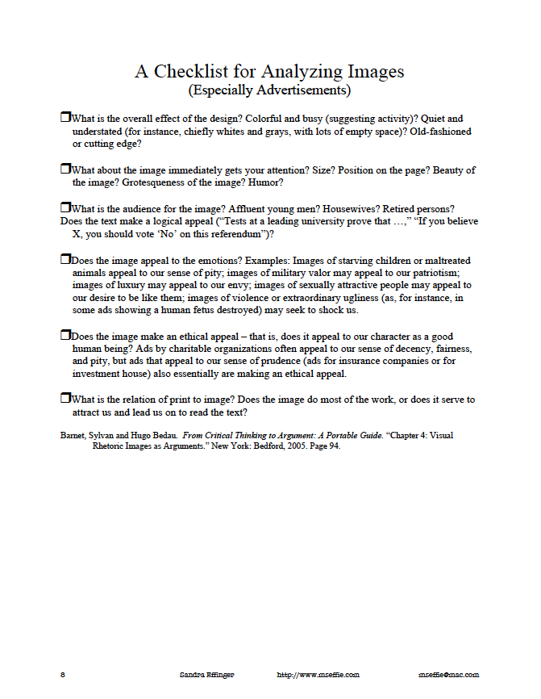
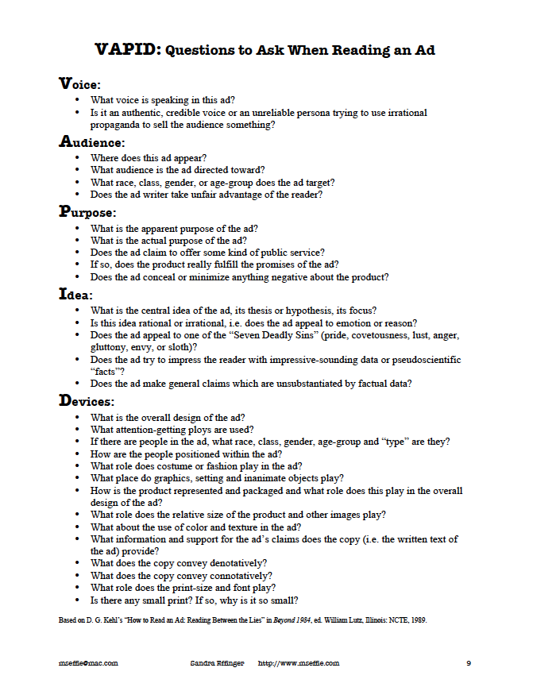
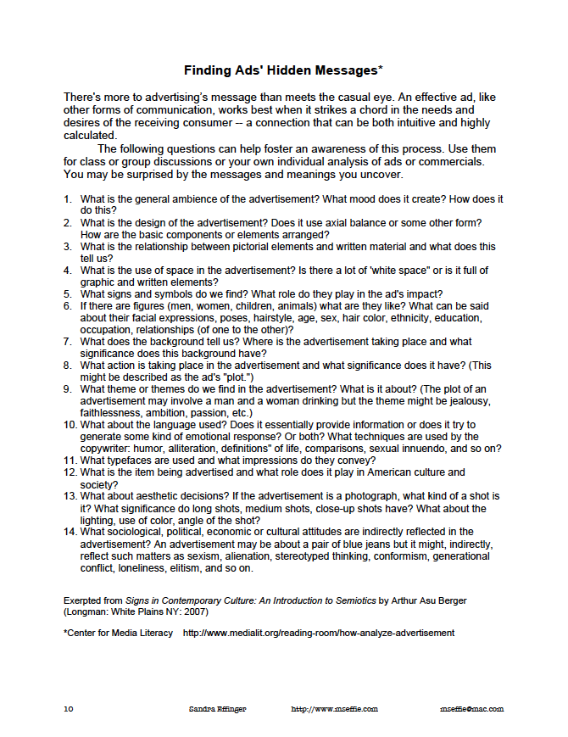
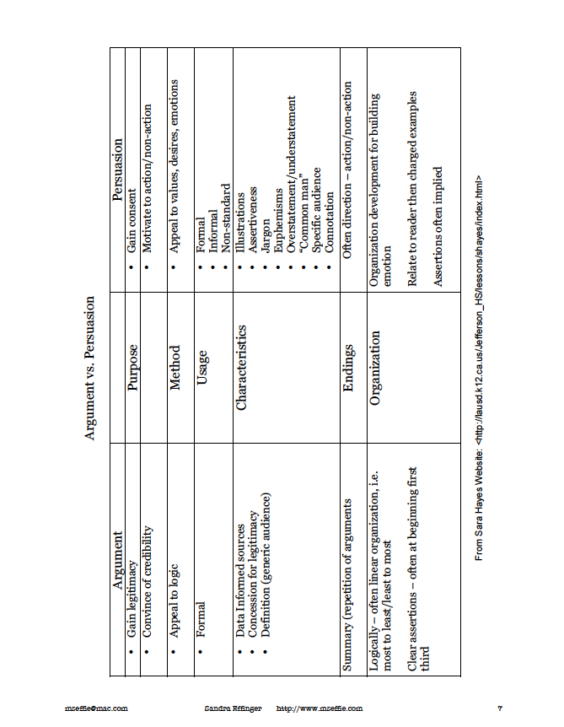

Persuasive Techniques in Advertising

- Bandwagon
Uses the argument that a person should believe or do something because “everybody else” does. Consumers buy the product because they want to fit in. Consumers assume that if others buy it, the product must be good.

- Testimonial
Uses a celebrity or famous person to endorse a product
Consumers transfer admiration or respect for the celebrity to the product.

- Emotional Appeals
Make viewers feel certain emotions, such as excitement sadness, or fear
Audience transfers that feeling to the product.

- Glittering Generalities
Words that are positive and appealing but too vague to have any real meaning, like “pure and natural.”

- Snob appeal
The opposite of the bandwagon technique, snob appeal makes the case that using the product means the consumer is better/smarter/richer than everyone else.

- Repetition
A product’s name or catchphrase is repeated over and over, with the goal of having it stick in the viewer or listener’s mind.

- Flattery
The advertiser appeals to the audience’s vanity by implying that smart/popular/rich people buy the product.

- Facts and figures
Using statistics, research, or other data to make the product appear to be better than its competitors.

- Special offer
The advertiser offers a discount, coupon, free gift, or other enticement to get people to buy a product.

- Urgency
The advertiser makes you feel like you need the product right away.

- Humor
Used to make audiences laugh, but provides little information about the product or service. Consumers remember the ad and associate positive feelings with the product.

- Individuality
Consumers celebrate their own style, or rebel against what others are doing. Consumers perceive the product as unique, stylish, or cool.

- Loaded Language
Words with strong positive or negative connotations such as “home”, “family”, “dishonest”, etc.

- Name-calling (Ad Hominem)
Attacks people or groups to discredit their ideas
Consumers focus on the attack rather than the issues

- Plain Folk
Shows ordinary people using or supporting a product or candidate. Implies that people “just like you” use the product.

- Product Comparison
Compares a product with the “inferior” competition
Consumers believe the feature product is superior.

- Weasel Words
Words and phrases aimed at creating an impression that a specific and/or meaningful statement has been made, when only a vague or ambiguous claim has been communicated, enabling the specific meaning to be denied if the statement is challenged.
Examples: Price is “as little as…”; “combats” toothe decay….; “virtually”; “up to” three times longer than…

